

**CAR RENTAL**

**Software Design Document**

– Hanoi, February 2023 –

***Thành viên trong nhóm***

***Lê Trung Đức - SE05390***

***Nguyễn Trí Trường Sơn - HE151167***

***Nguyễn Hữu Minh Đức - HE151166***

**I. Overview 4**

1. Code Packages/Namespaces 4

2. Database Design 4

1. Users 6

2. Role 6

3. Customers 6

4. Rentals 7

5. Cars 7

6. Categories 7

7. Transactions 7

**II. Code Designs 8**

1. Login 8

a. Class Diagram 8

b. Class Specifications 9

XYZ Class 9

c. Sequence Diagram(s) 9

d. Database queries 10

2. User Register 10

a. Class Diagram 11

b. Class Specifications 11

XYZ Class 12

c. Sequence Diagram(s) 12

d. Database queries 13

3. Reset Password 13

a. Class Diagram 14

b. Class Specifications 14

XYZ Class 15

c. Sequence Diagram(s) 15

d. Database queries 15

4. Public/Car List 16

a. Class Diagram 16

b. Class Specifications 16

XYZ Class 16

c. Sequence Diagram(s) 17

d. Database queries 17

5. Public/Car Details 18

a. Class Diagram 18

b. Class Specifications 18

XYZ Class 18

c. Sequence Diagram(s) 19

d. Database queries 19

6. Public/Payment 20

a. Class Diagram 20

b. Class Specifications 20

XYZ Class 20

c. Sequence Diagram(s) 21

d. Database queries 21

7. Admin/Dashboard 22

a. Class Diagram 22

b. Class Specifications 22

XYZ Class 22

c. Sequence Diagram(s) 23

d. Database queries 23

8. Admin/ListCar 24

a. Class Diagram 24

b. Class Specifications 24

XYZ Class 24

c. Sequence Diagram(s) 25

d. Database queries 25

9. Admin/CarDetail 26

a. Class Diagram 26

b. Class Specifications 26

XYZ Class 26

c. Sequence Diagram(s) 27

d. Database queries 27

# I. Overview

## 1. Code Packages/Namespaces

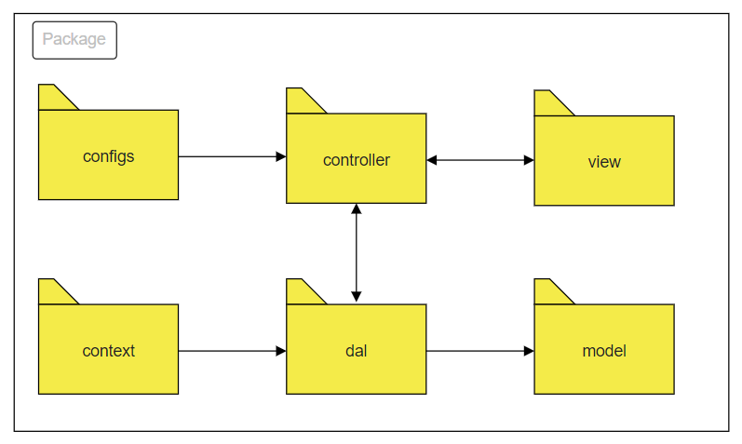

***Package descriptions & package class naming conventions***

| **No** | **Package** | **Description** |
| --- | --- | --- |
| *01* | *controller* | *Acts as a go-between for the service layer and the Front-end, passing on different input requests*  *<Class naming convention>* |
| *02* | *dal* | *This component is used to get data directly FROM the database*  *<Class naming convention>* |
| *03* | *configs* | *This component helps define configuration*  *<Class naming convention>* |
| *04* | *context* | *This component helps connect database*  *<Class naming convention>* |
| *05* | *model* | *This component includes interfaces used to receive data retrieved FROM the database and classes used to receive data*  *<Class naming convention>* |
| *05* | *view* | *This component display front-end*  *<Class naming convention>* |

## 2. Database Design

**2.1 Database Schema**

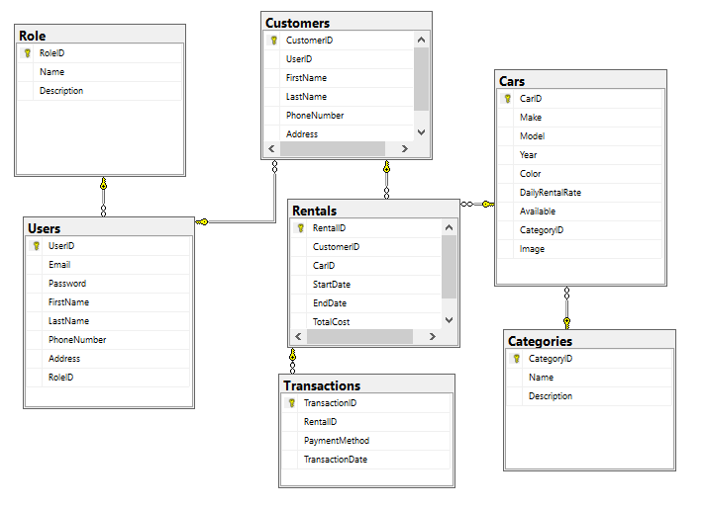

***Table descriptions & package class naming conventions are as below***

| **No** | **Table** | **Description** |
| --- | --- | --- |
| *01* | *Users* | *This table contains information about the users of the system, including their email address, password, name, phone number, address, and role.*  *- Primary keys: UserID*  *- Foreign keys: RoleID* |
| *02* | *Role* | *This table contains information about the various roles that users can have within the system, such as "admin" or "customer service representative".*  *- Primary keys: RoleID* |
| *03* | *Customers* | *This table contains information about the customers of the rental service, including their name, phone number, and address.*  *- Primary keys: CustomerID*  *- Foreign keys: UserID* |
| *04* | *Rentals* | *This table contains information about the car rentals in the system, including the customer who rented the car, the car that was rented, the rental dates, and the total cost.*  *- Primary keys: RentalID*  *- Foreign keys: CustomerID, CarID* |
| *05* | *Cars* | *This table contains information about the cars available for rent, including the make, model, year, color, daily rental rate, availability status, category, and image.*  *- Primary keys: CarID*  *- Foreign keys: CategoryID* |
| *06* | *Categories* | *This table contains information about the various categories of cars in the system, such as "economy" or "luxury".*  *- Primary keys: CategoryID* |
| *07* | *Transactions* | *This table contains information about the financial transactions associated with rentals, including the rental ID, payment method, and transaction date.*  *- Primary keys: TransactionID*  *- Foreign keys: RentalID* |

**2.2 Database table**

## 1. Users

| **#** | **Field name** | **Type** | **Size** | **Unique** | **Not Null** | **PK/FK** | **Notes** |
| --- | --- | --- | --- | --- | --- | --- | --- |
| 1 | UserID | int |  | v | v | PK |  |
| 2 | Email | String | 255 |  | v |  |  |
| 3 | Password | String | 255 |  | v |  |  |
| 4 | FirstName | String | 50 |  |  |  |  |
| 5 | LastName | String | 50 |  |  |  |  |
| 6 | PhoneNumber | String | 20 |  |  |  |  |
| 7 | Address | String | 255 |  |  |  |  |
| 8 | RoleId | int |  |  |  | FK |  |

## 2. Role

| **#** | **Field name** | **Type** | **Size** | **Unique** | **Not Null** | **PK/FK** | **Notes** |
| --- | --- | --- | --- | --- | --- | --- | --- |
| 1 | RoleID | int |  | v | v | PK |  |
| 2 | Name | String | 50 |  | v |  |  |
| 3 | Description | String | 255 |  |  |  |  |

## 3. Customers

| **#** | **Field name** | **Type** | **Size** | **Unique** | **Not Null** | **PK/FK** | **Notes** |
| --- | --- | --- | --- | --- | --- | --- | --- |
| 1 | CustomerID | int |  | v | v | PK |  |
| 2 | UserID | int |  |  | v | FK |  |
| 3 | FirstName | String | 50 |  |  |  |  |
| 4 | LastName | String | 50 |  |  |  |  |
| 5 | PhoneNumber | String | 20 |  |  |  |  |
| 6 | Address | String | 255 |  |  |  |  |

## 

## 

## 4. Rentals

| **#** | **Field name** | **Type** | **Size** | **Unique** | **Not Null** | **PK/FK** | **Notes** |
| --- | --- | --- | --- | --- | --- | --- | --- |
| 1 | RentalID | int |  | v | v | PK |  |
| 2 | CustomerID | int |  |  | v | FK |  |
| 3 | CarID | int |  |  | v | FK |  |
| 4 | StartDate | Date |  |  |  |  |  |
| 5 | EndDate | Date |  |  |  |  |  |
| 6 | TotalCost | double |  |  |  |  |  |

## 5. Cars

| **#** | **Field name** | **Type** | **Size** | **Unique** | **Not Null** | **PK/FK** | **Notes** |
| --- | --- | --- | --- | --- | --- | --- | --- |
| 1 | CarID | int |  | v | v | PK |  |
| 2 | Make | String | 50 |  | v |  |  |
| 3 | Model | String | 50 |  | v |  |  |
| 4 | Year | int |  |  |  |  |  |
| 5 | Color | String | 50 |  |  |  |  |
| 6 | RentalRate | double |  |  |  |  |  |
| 7 | Available | boolean |  |  |  |  |  |
| 8 | CategoryID | int |  |  |  | FK |  |
| 9 | Image | String | Max |  |  |  |  |

## 6. Categories

| **#** | **Field name** | **Type** | **Size** | **Unique** | **Not Null** | **PK/FK** | **Notes** |
| --- | --- | --- | --- | --- | --- | --- | --- |
| 1 | CategoryID | int |  | v | v | PK |  |
| 2 | Name | String | 50 |  | v |  |  |
| 3 | Description | String | 255 |  | v |  |  |

## 7. Transactions

| **#** | **Field name** | **Type** | **Size** | **Unique** | **Not Null** | **PK/FK** | **Notes** |
| --- | --- | --- | --- | --- | --- | --- | --- |
| 1 | TransactionID | int |  | v | v | PK |  |
| 2 | RentalID | int |  |  | v | FK |  |
| 3 | PaymentMethod | String | 50 |  |  |  |  |
| 4 | TransactionDate | Date |  |  |  |  |  |

# II. Code Designs

## 1. Login

### a. Class Diagram

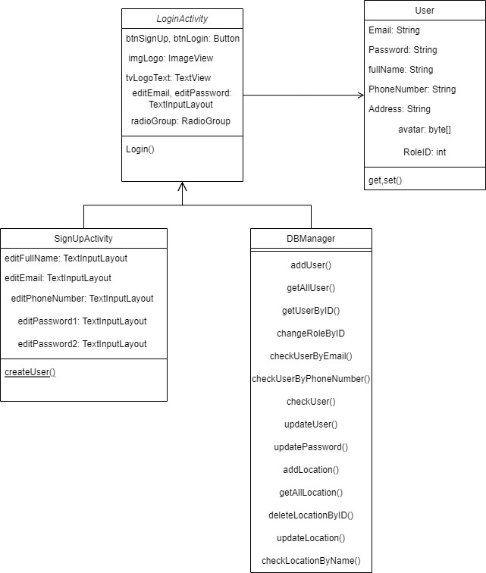

### b. Class Specifications

#### XYZ Class

#### 

| **No** | **Method** | **Description** |
| --- | --- | --- |
| *01* | *Login* | *Login user into system* |
|  |  |  |
|  |  |  |
|  |  |  |
|  |  |  |
|  |  |  |

### 

### c. Sequence Diagram(s)

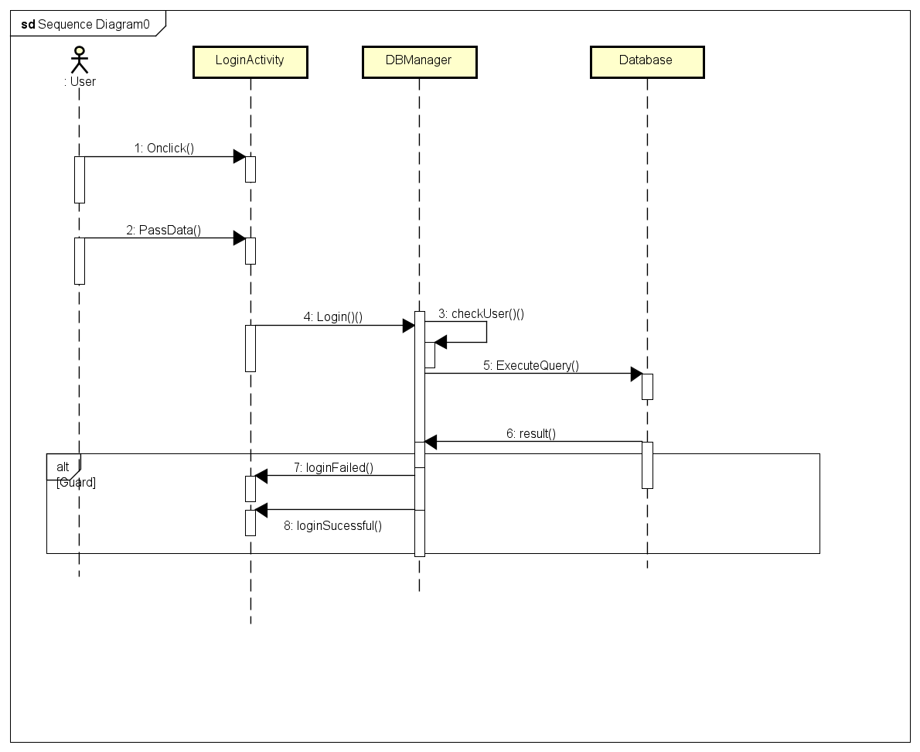

### d. Database queries

SELECT * FROM Users

WHERE email = ? and password = ?

## 2. User Register

### a. Class Diagram

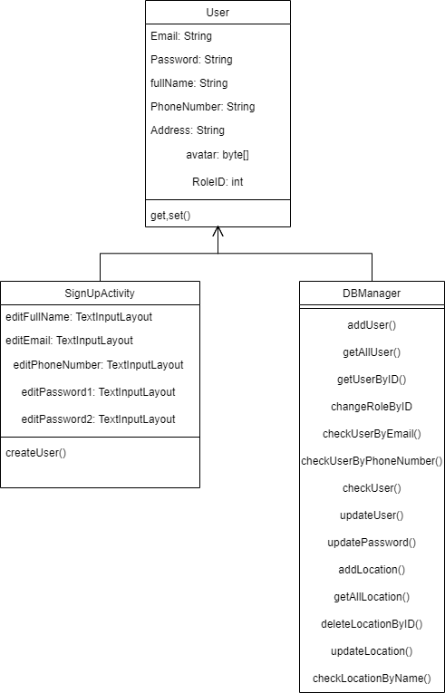

### b. Class Specifications

| **No** | **Method** | **Description** |
| --- | --- | --- |
| *01* | *createUser* | *Add new user into database* |
|  |  |  |
|  |  |  |
|  |  |  |
|  |  |  |
|  |  |  |

### 

#### XYZ Class

### c. Sequence Diagram(s)

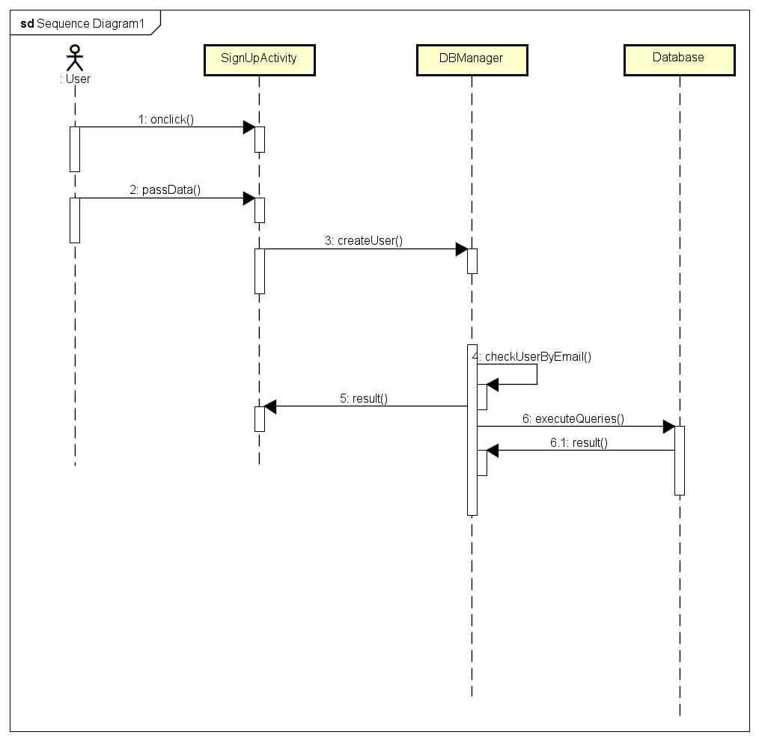

### d. Database queries

INSERT INTO Users (Email,password,FirstName,LastName,PhoneNumber,Address,RoleID)

VALUES(?,?,?,?,?,?,?)

## 3. Reset Password

### a. Class Diagram

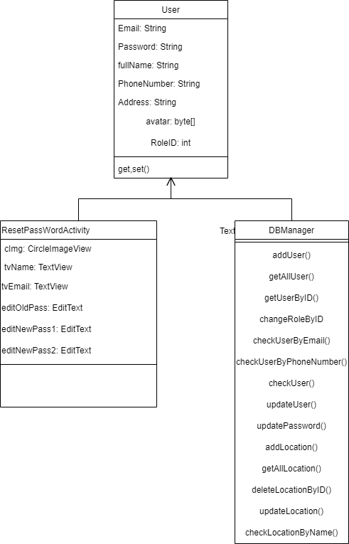

### b. Class Specifications

#### XYZ Class

#### 

| **No** | **Method** | **Description** |
| --- | --- | --- |
| *01* | *updatePassword* | *update new password to database* |
|  |  |  |
|  |  |  |
|  |  |  |
|  |  |  |
|  |  |  |

### c. Sequence Diagram(s)

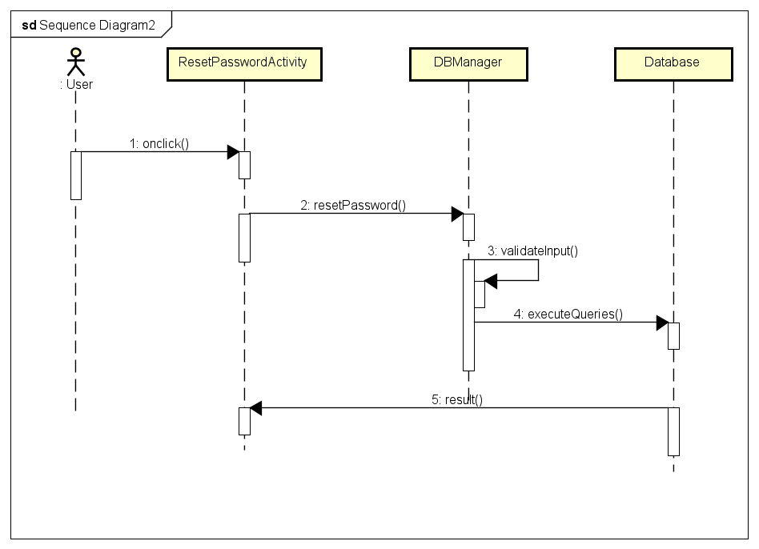

### d. Database queries

1.SELECT * FROM Users

WHERE UserID=?

2.UPDATE Users

SET Password

WHERE UserID=?

## 4. Public/Car List

### a. Class Diagram

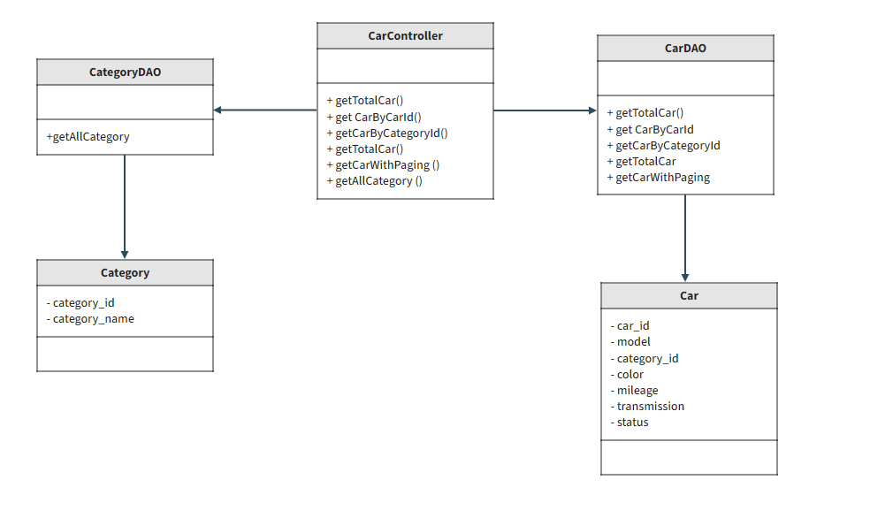

### b. Class Specifications

#### XYZ Class

| **No** | **Method** | **Description** |
| --- | --- | --- |
| *01* | *getTotalCar* | *get all car* |
| *02* | *getCarByCarId* | *get car by car id* |
| *03* | *getCarByCategoryId* | *get car by category id* |
| *04* | *getCarWithPaging* | *git car with paging* |
| *05* | *getTotalCar* | *get total car* |
| *06* | *getAllCategory* | *get all category* |

### c. Sequence Diagram(s)

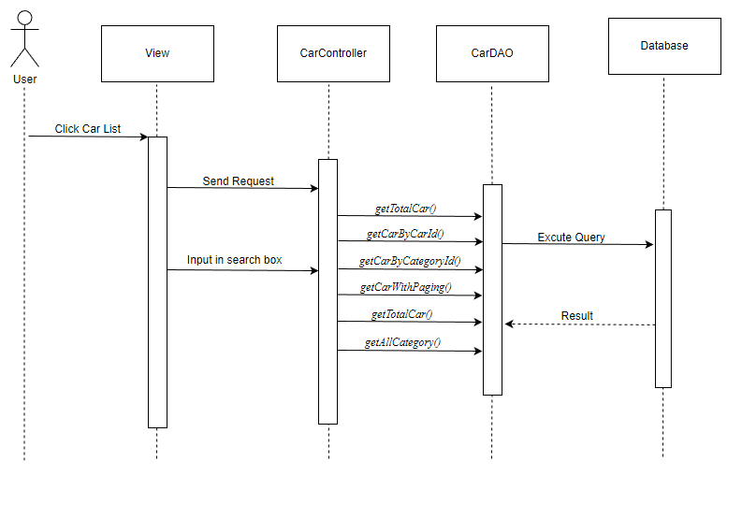

### d. Database queries

Select * from Car where category_id = ?

Select * from Car where car_id = ?

Select count(*) from Car "

+ "where category_id " + categoryId + " and status = 1 and name like N'%" + searchKey + "%'\n

select * from Car\n"

+ "where category_id " + categoryId + " and status = 1 and name like N'%" + searchKey + "%'\n"

+ " order by " + value + " " + type + " offset (?-1)*? row fetch next ? row only

Select * from Category and status = 1

## 5. Public/Car Details

### a. Class Diagram

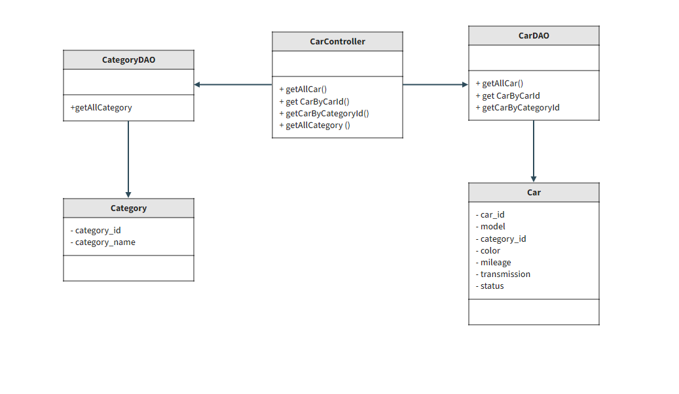

### b. Class Specifications

#### XYZ Class

#### 

| **No** | **Method** | **Description** |
| --- | --- | --- |
| *01* | *getAllCar* | *get all car* |
| *02* | *getCarByCategoryId* | *get car by category id* |
| *03* | *getCarByCarId* | *get car by carid* |
| *04* | *getAllCategory* | *get all category* |

### 

### c. Sequence Diagram(s)

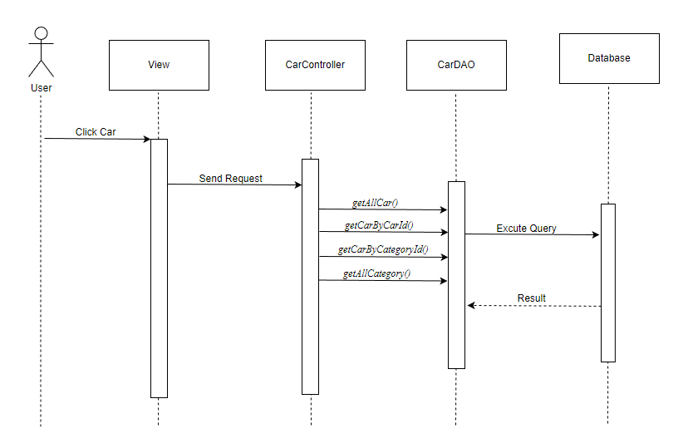

### d. Database queries

Select * from Car where category_id = ?

Select * from Car where car_id = ?

Select * from Category and status = 1

## 6. Public/Payment

### a. Class Diagram

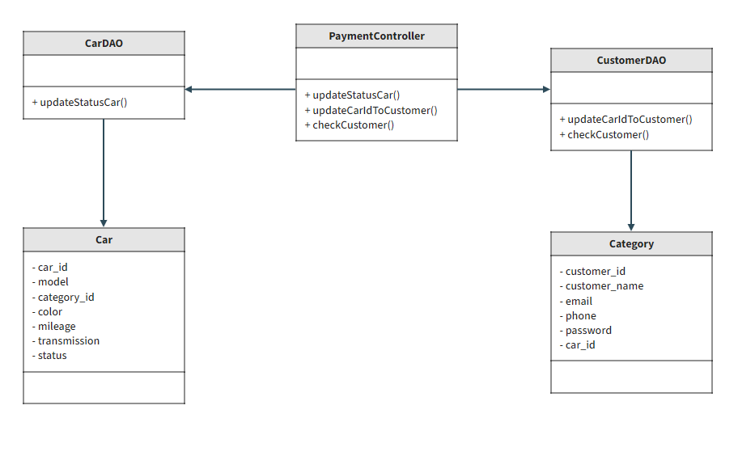

### b. Class Specifications

#### XYZ Class

| **No** | **Method** | **Description** |
| --- | --- | --- |
| *01* | *updateStatusOrder()* | *Update status for order selected* |
| *02* | *updateCarIdToCustomer()* | *Update car id for customer selected* |
| *03* | *checkCustomer()* | *Check customer existed* |

### c. Sequence Diagram(s)

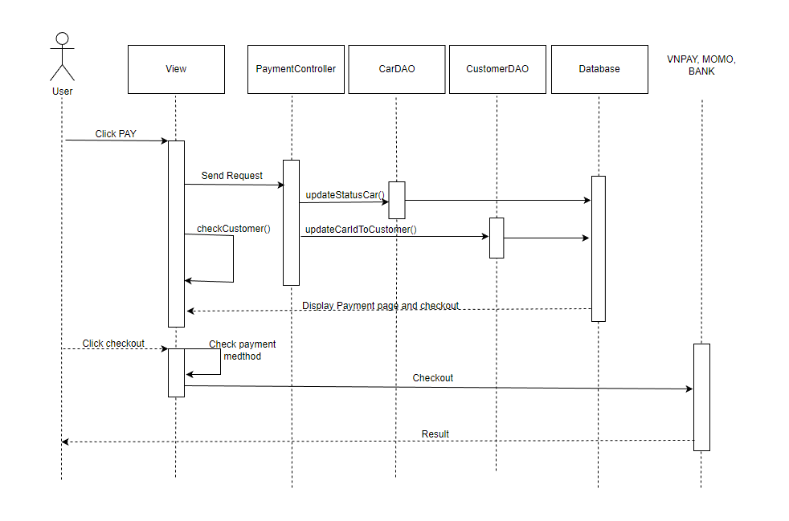

### d. Database queries

* UPDATE Car SET status = ? WHERE car_id = ?
* UPDATE Customer SET car_id ? WHERE customer_id = ?
* SELECT customer_id, customer_name, email, mobile FROM Customer

WHERE customer_name = ? and email = ? and mobile = ?

## 7. Admin/Dashboard

### a. Class Diagram

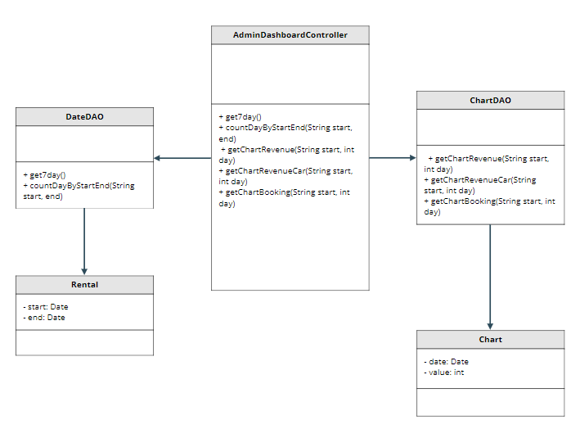

### b. Class Specifications

#### XYZ Class

| **No** | **Method** | **Description** |
| --- | --- | --- |
| *01* | *get7day()* | *Get last seven days* |
| *02* | *countDayByStartEnd()* | *Count the number of days difference between start and end* |
| *03* | *getRevenue()* | *Get statistics revenue chart from start date to end date of all* |
| *04* | *getChartRevenueCar()* | *Get statistics revenue chart from start date to end date of each car* |
| *05* | *getChartBooking()* | *Get statistics revenue chart from start date to end date of each customer* |

### c. Sequence Diagram(s)

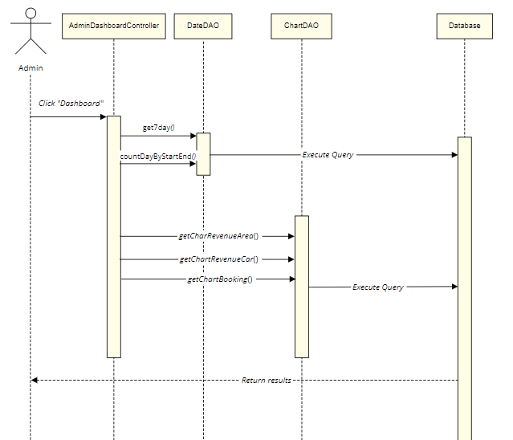

### d. Database queries

SELECT * FROM cars WHERE availability = 'available'

SELECT * FROM rentals WHERE customer_id = <customer_id>

SELECT SUM(total_cost) FROM rentals

SELECT category, COUNT(*) AS count FROM rentals JOIN cars ON rentals.car_id = cars.car_id GROUP BY category ORDER BY count DESC LIMIT 1

UPDATE cars SET availability = 'unavailable' WHERE car_id = <car_id>

## 8. Admin/ListCar

### a. Class Diagram

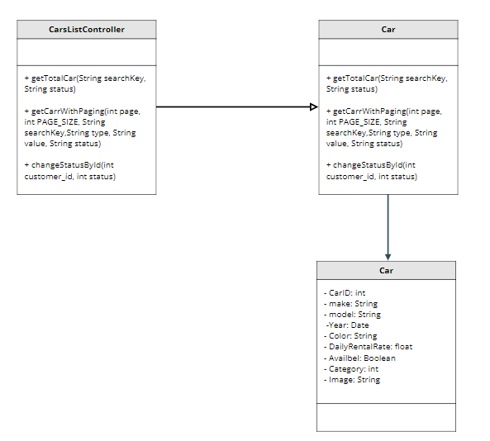

### b. Class Specifications

#### XYZ Class

| **No** | **Method** | **Description** |
| --- | --- | --- |
| *01* | *getTotlaCar()* | *Get total car in system* |
| *02* | *getCarWithPaging()* | *Get all car list is paginated* |
| *03* | *changeStatus()* | *Change status of specific car* |

### c. Sequence Diagram(s)

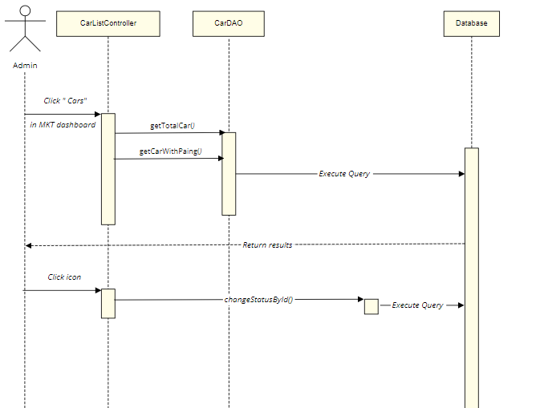

### d. Database queries

UPDATE Car SET status = ? WHERE car_id = ?

Select * from Car where car_id = ?

select * from Car where category_id " + categoryId + " and status = 1 and name like N'%" + searchKey + "%'\n"

+ " order by " + value + " " + type + " offset (?-1)*? row fetch next ? row only

## 9. Admin/CarDetail

### a. Class Diagram

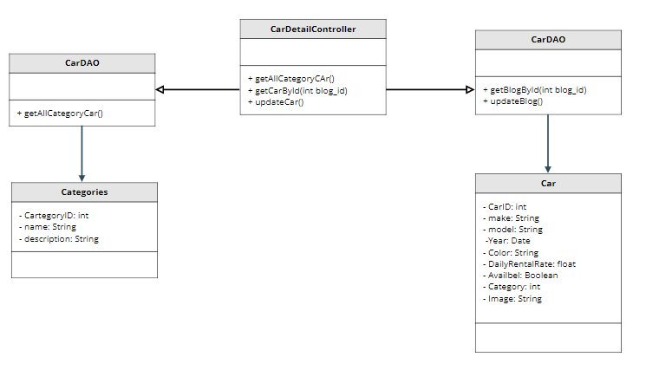

### b. Class Specifications

#### XYZ Class

| **No** | **Method** | **Description** |
| --- | --- | --- |
| *01* | *getAllCategoryCar()* | *Get all category of car in system* |
| *02* | *getCarById()* | *Get specific car by id* |
| *03* | *updateCar()* | *Update specific car with new value* |

### c. Sequence Diagram(s)

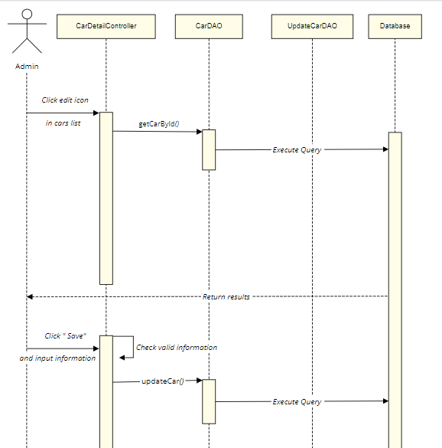

### d. Database queries

UPDATE Car SET specific = ? WHERE car_id = ?

Select * from Car where car_id = ?

select * from Category